# **Create ASG with custom AMI then update the AMI in ASG to reflect updated AMI changes**

For this we first create one EC2 instance with t2.micro which will have spring boot “**helloworld**” java artifact and running as a service. Open the post 8080 on the ec2 instance as service will be running on that post.

The manual steps are as follows

1. Create an EC2 instance and run the service helloworld on that node
2. Create a custom AMI “**Demo_AMI**” from the EC2 instance which we created in step 1.
3. Create Launch Configuration with “**Demo_AMI**”
4. Create a ASG with Application Load Balancer having “**Demo_AMI**” as Launch Configuration
5. Create a Updated_AMI with updated EC2 springboot application.
6. Create a New Launch Configuration with **Updated_AMI**
7. Edit the scaling group and update it with Launch Configuration : “**Updated_AMI**”
8. Check the service status

**1. Create an EC2 instance of t2.micro and run the service helloworld on that node**

**# yum install git java-1.8.0-openjdk-devel maven –y**

**# cd /opt**

**# git clone** [**https://github.com/tushardashpute/springboohello-CICD.git**](https://github.com/tushardashpute/springboohello-CICD.git)

Cloning into 'springboohello-CICD'...

remote: Enumerating objects: 53, done.

remote: Counting objects: 100% (53/53), done.

remote: Compressing objects: 100% (47/47), done.

remote: Total 53 (delta 16), reused 25 (delta 2), pack-reused 0

Unpacking objects: 100% (53/53), done.

# **mvn clean install**

[root@ip-172-31-54-101 springboohello-CICD]**# cd target**

[root@ip-172-31-54-101 target]# **ls -ltr**

total 15860

drwxr-xr-x 3 root root 19 Apr 26 08:17 classes

drwxr-xr-x 3 root root 25 Apr 26 08:17 generated-sources

-rwxr--r-- 1 root root 16233145 Apr 26 08:17 gs-spring-boot-0.1.0.jar

-rw-r--r-- 1 root root 3280 Apr 26 08:17 gs-spring-boot-0.1.0.jar.original

drwxr-xr-x 2 root root 28 Apr 26 08:17 maven-archiver

drwxr-xr-x 3 root root 35 Apr 26 08:17 maven-status

# cd /opt

[root@ip-172-31-54-101 opt**]# cat gs-spring-boot**

#!/bin/sh

sudo /usr/bin/java -jar /opt/gs-spring-boot.jar &

# chmod +x gs-spring-boot

[root@ip-172-31-54-101 opt**]# ln -s /opt/springboohello-CICD/target/gs-spring-boot-0.1.0.jar /opt/gs-spring-boot.jar**

[root@ip-172-31-54-101 opt**]# ll gs-spring-boot.jar**

lrwxrwxrwx 1 root root 56 Apr 26 09:00 gs-spring-boot.jar -> /opt/springboohello-CICD/target/gs-spring-boot-0.1.0.jar

[root@ip-172-31-54-101 opt**]# cat /etc/systemd/system/helloworld.service**

[Unit]

Description=A Spring Boot application

After=syslog.target

[Service]

Type=forking

Environment=JAVA_HOME=/usr/lib/jvm/java-1.8.0-openjdk-1.8.0.282.b08-1.amzn2.0.1.x86_64/jre

ExecStart=/opt/gs-spring-boot

SuccessExitStatus=143

TimeoutStopSec=10

Restart=on-failure

RestartSec=5

[Install]

WantedBy=multi-user.target

[root@ip-172-31-54-101 opt]# chkconfig helloworld on

Note: Forwarding request to 'systemctl enable helloworld.service'.

[root@ip-172-31-54-101 opt]**# service helloworld start**

Redirecting to /bin/systemctl start helloworld.service

[root@ip-172-31-54-101 target**]# jps**

4147 jar

4187 Jps

[root@ip-172-31-54-101 target**]# ps -ef|grep -i jar**

root 4147 3417 26 08:21 pts/0 00:00:07 java -jar gs-spring-boot-0.1.0.jar

root 4198 3417 0 08:22 pts/0 00:00:00 grep --color=auto -i jar

[root@ip-172-31-54-101 target]**# netstat -na|grep -i 33333**

tcp6 0 0 :::33333 :::* LISTEN

**2. Create a custom AMI “Demo_AMI” from the EC2 instance which we created in step 1.**

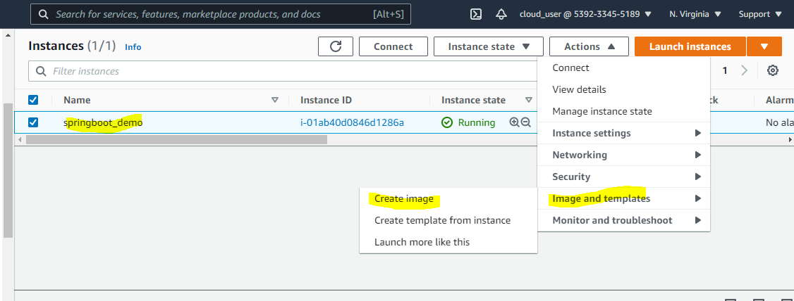

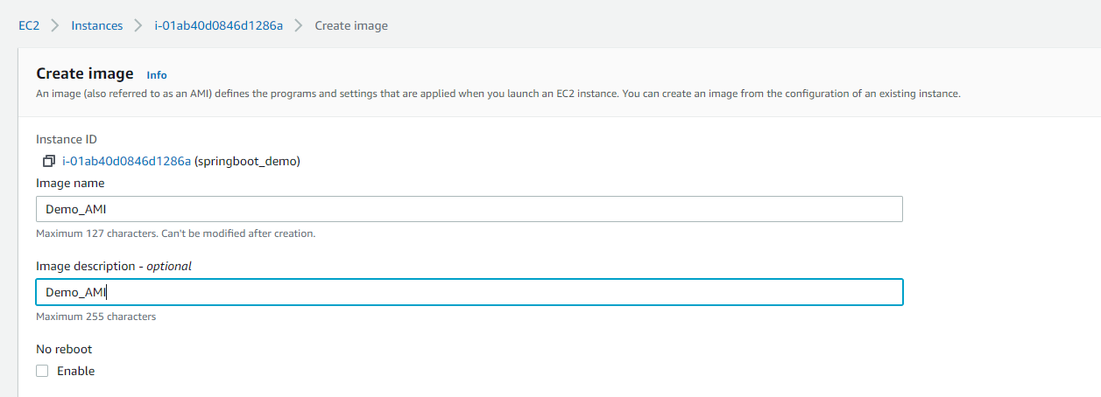

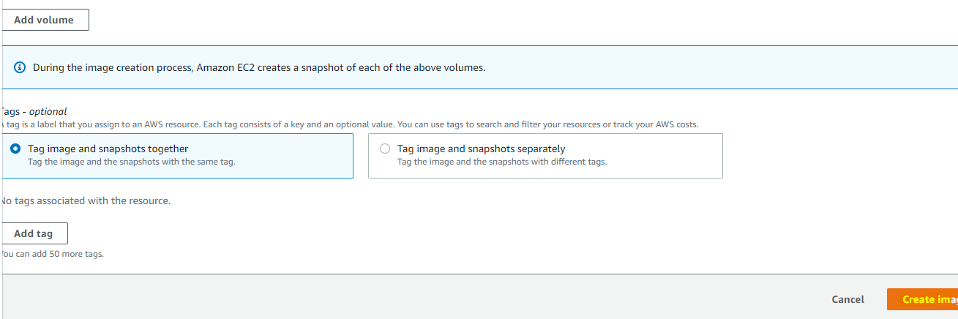

Wait till image become available.

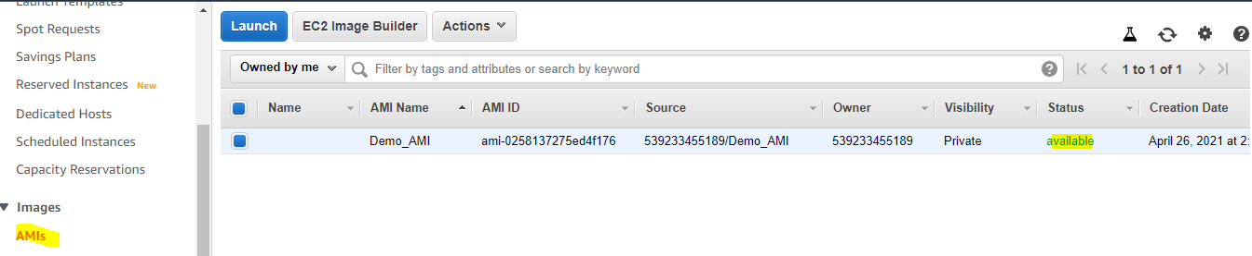

**3.Create Launch Configuration with “Demo_AMI”**

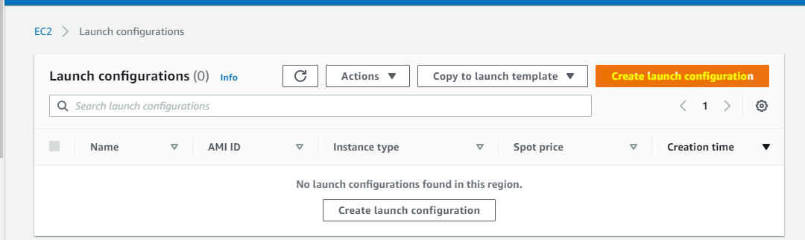

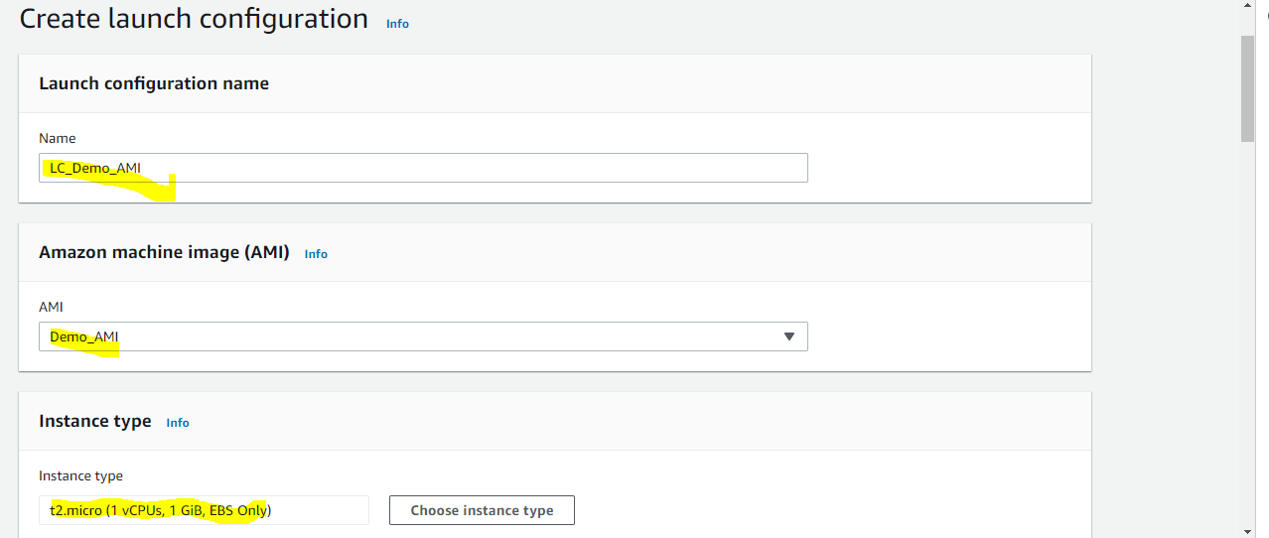

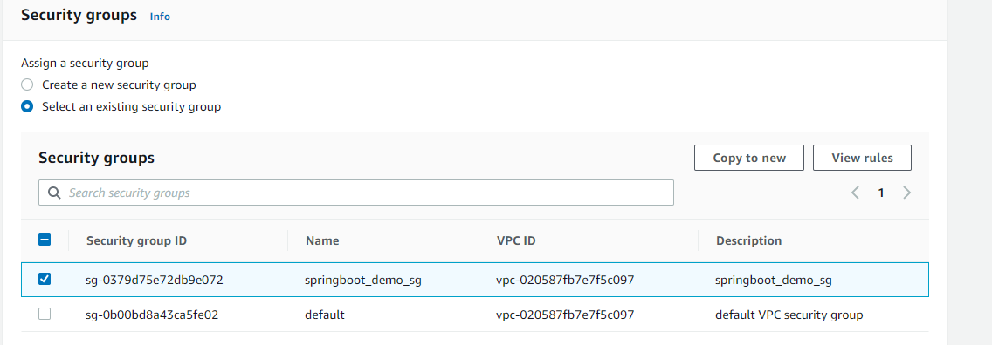

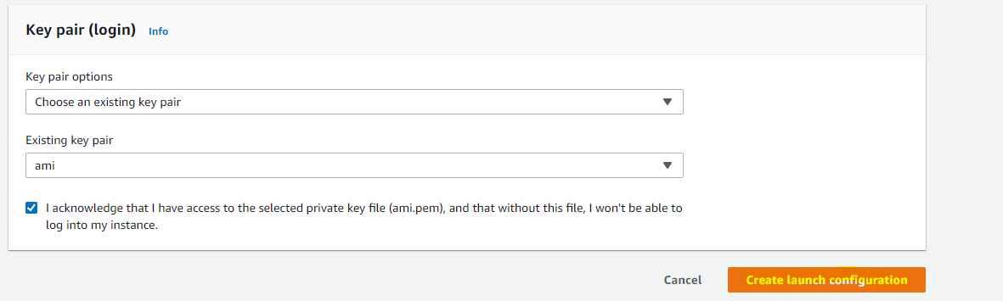

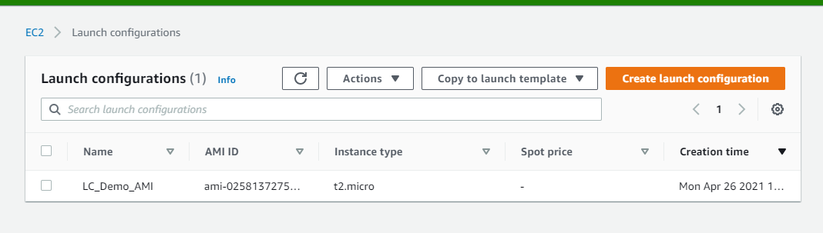

**4. Create Load Balancer and Target Group** :

Here our application is running on port 33333 but using target group we are rerouting the traffic from 33333 to default port 80 and also we configuring path based health check to check if path /listallcustomers is accessible or not.

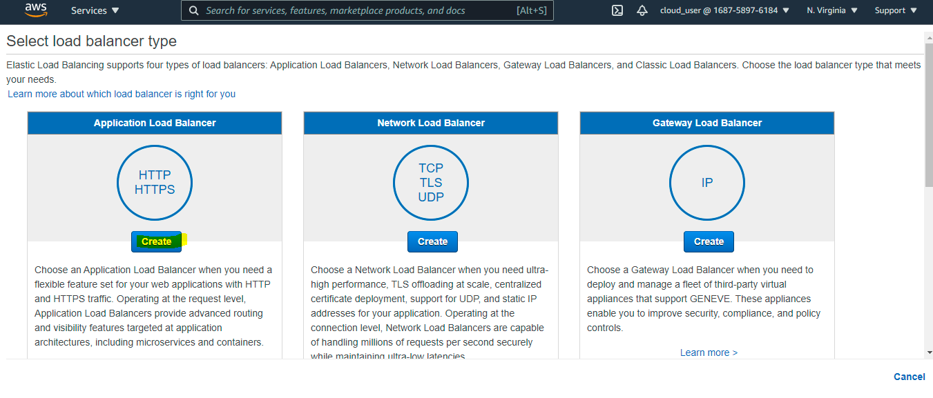

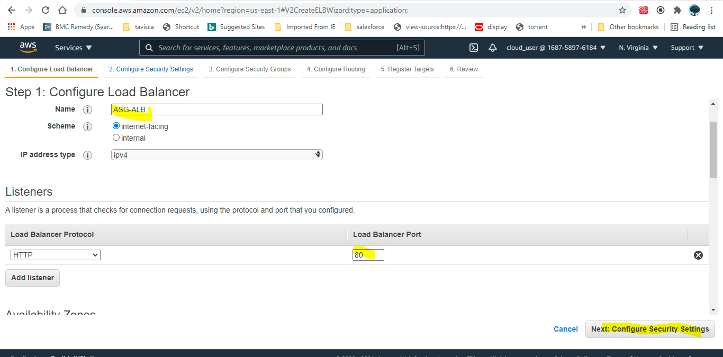

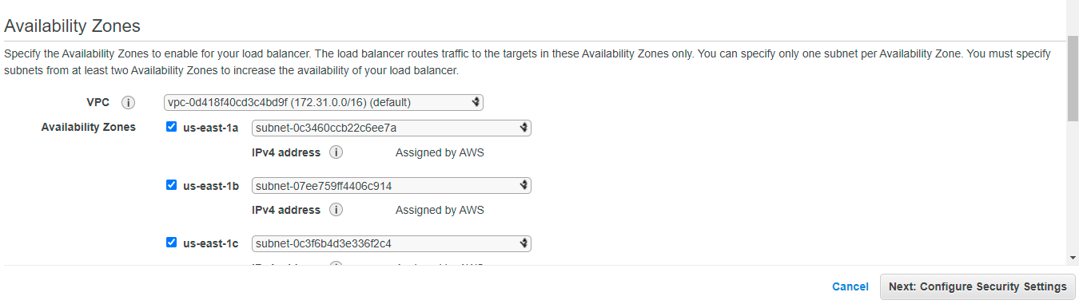

This security group must have http and 33333 port traffic allowed.

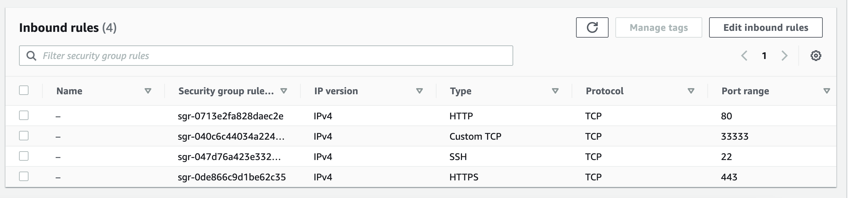

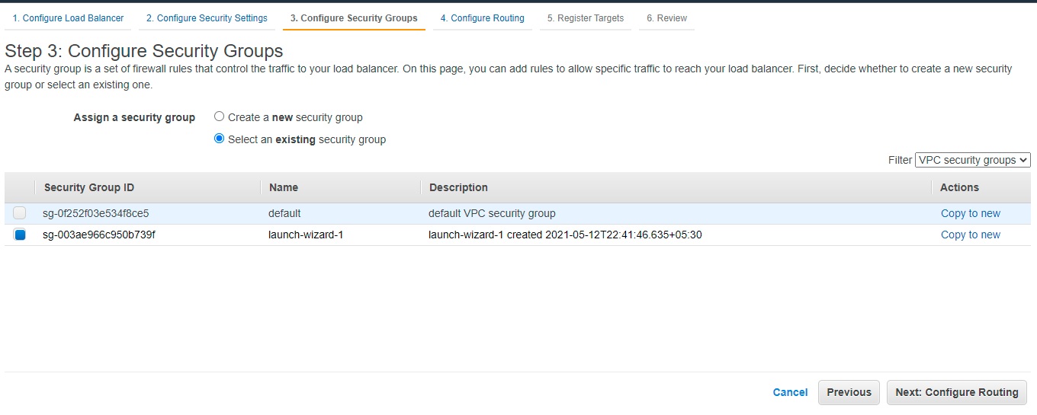

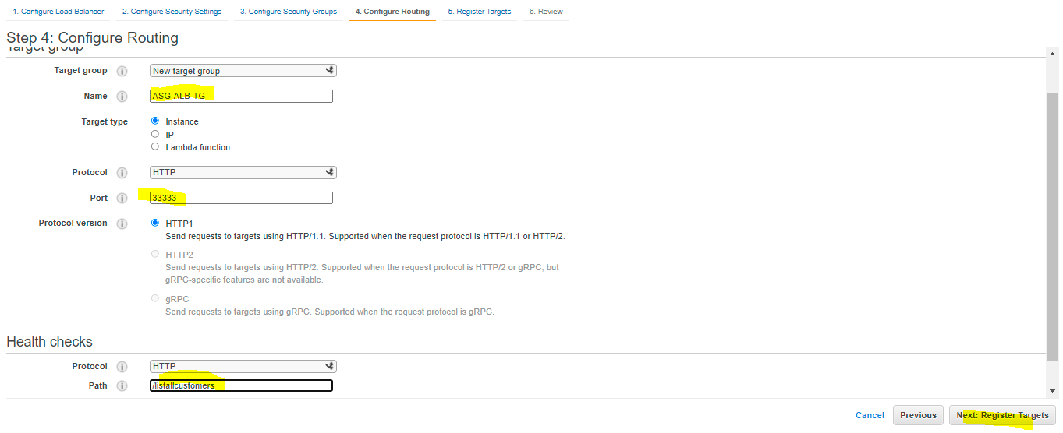

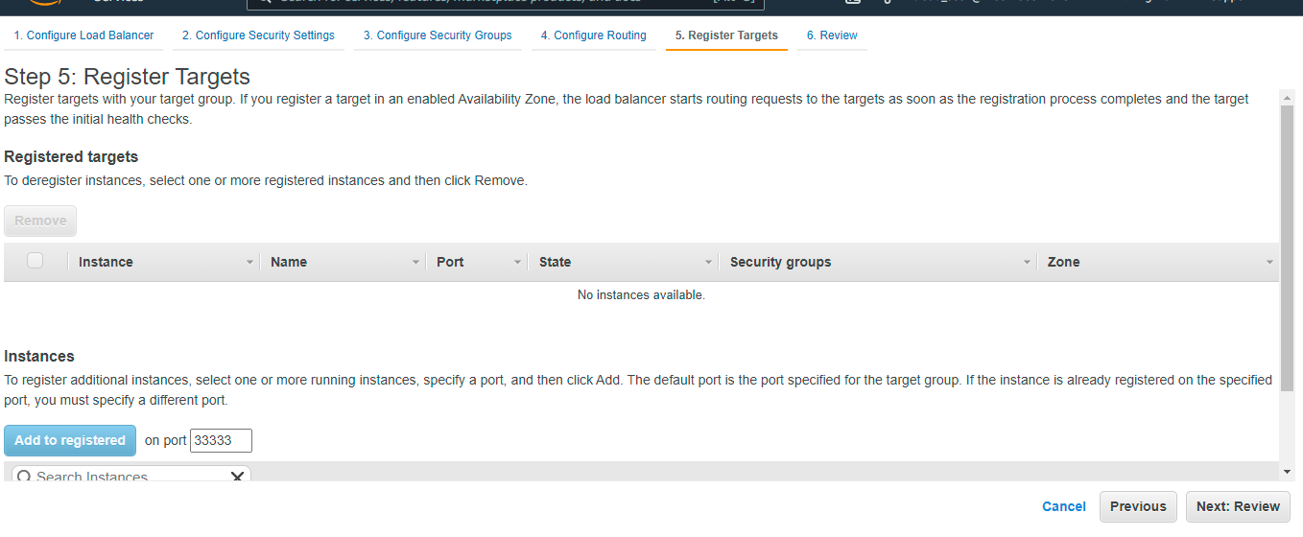

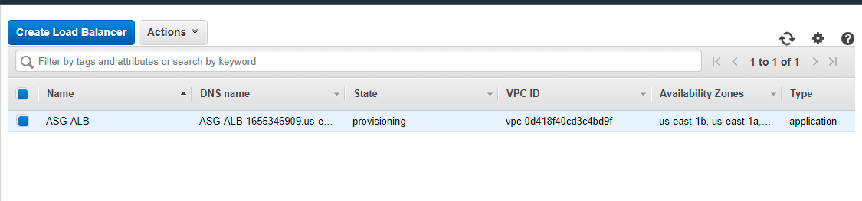

**5. Create a ASG with Application Load Balancer having “Demo_AMI” as Launch Configuration**

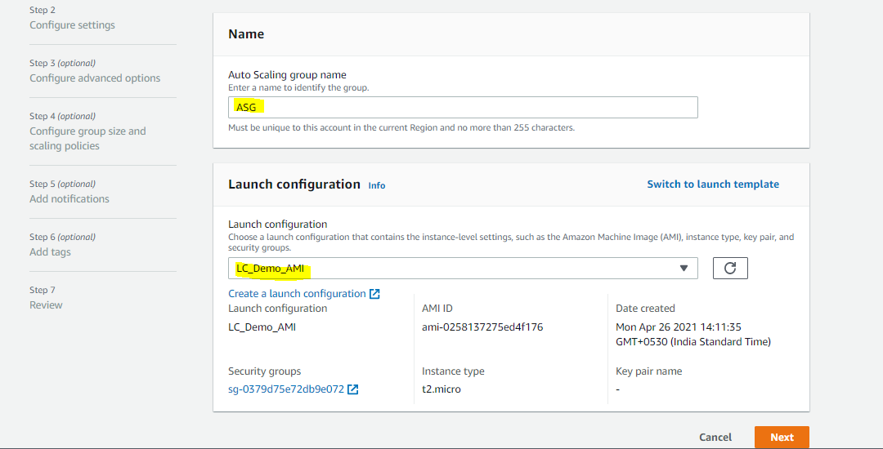

Here I am using the default VPC.

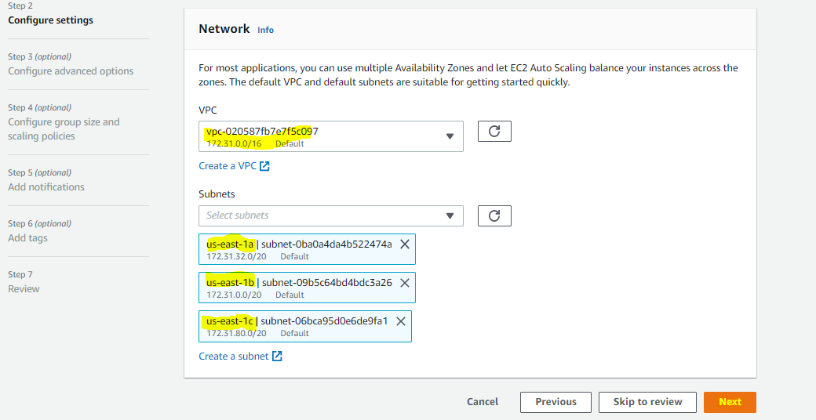

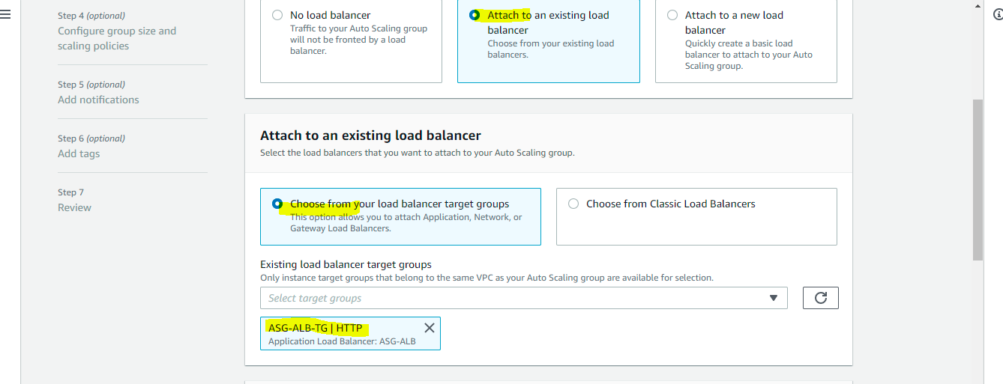

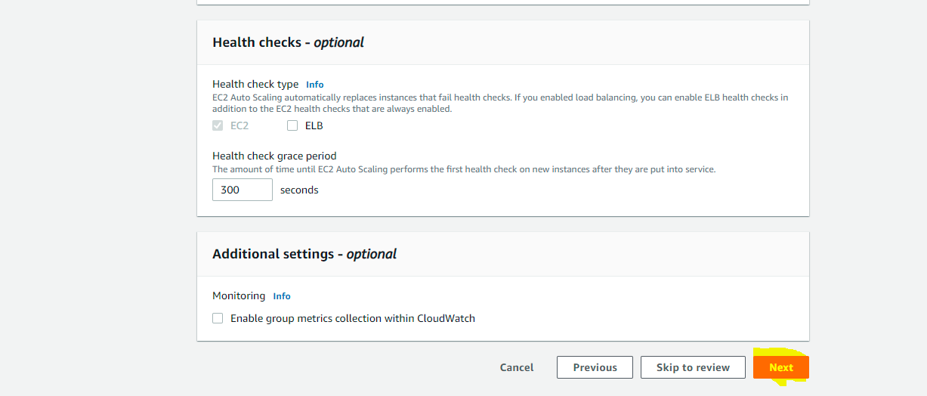

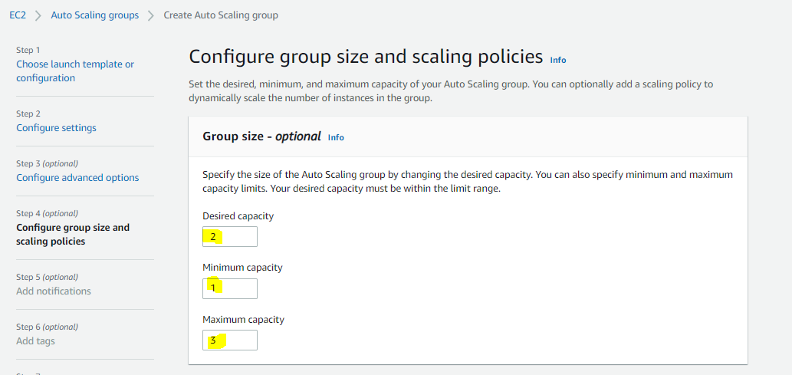

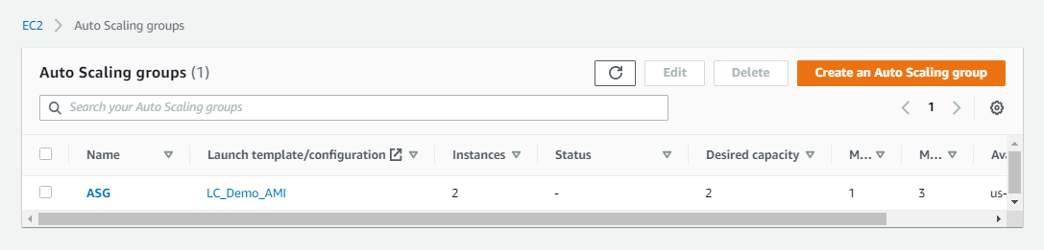

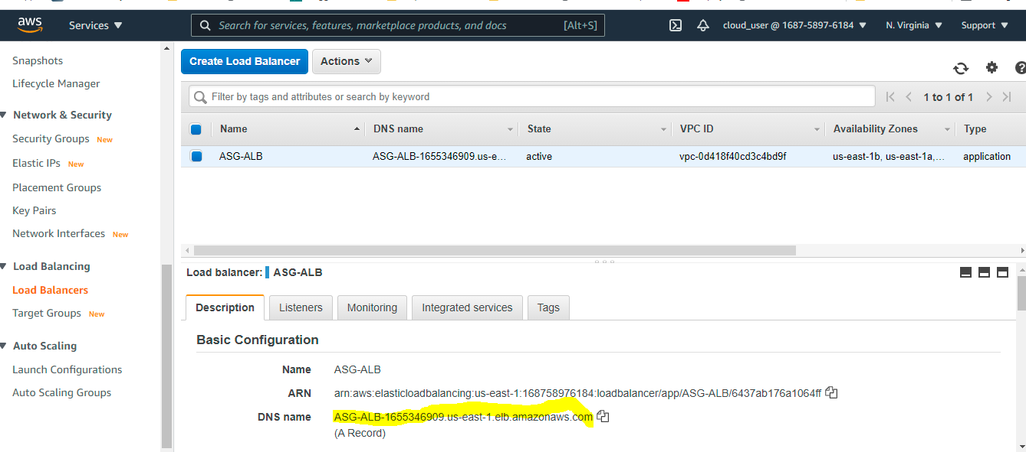

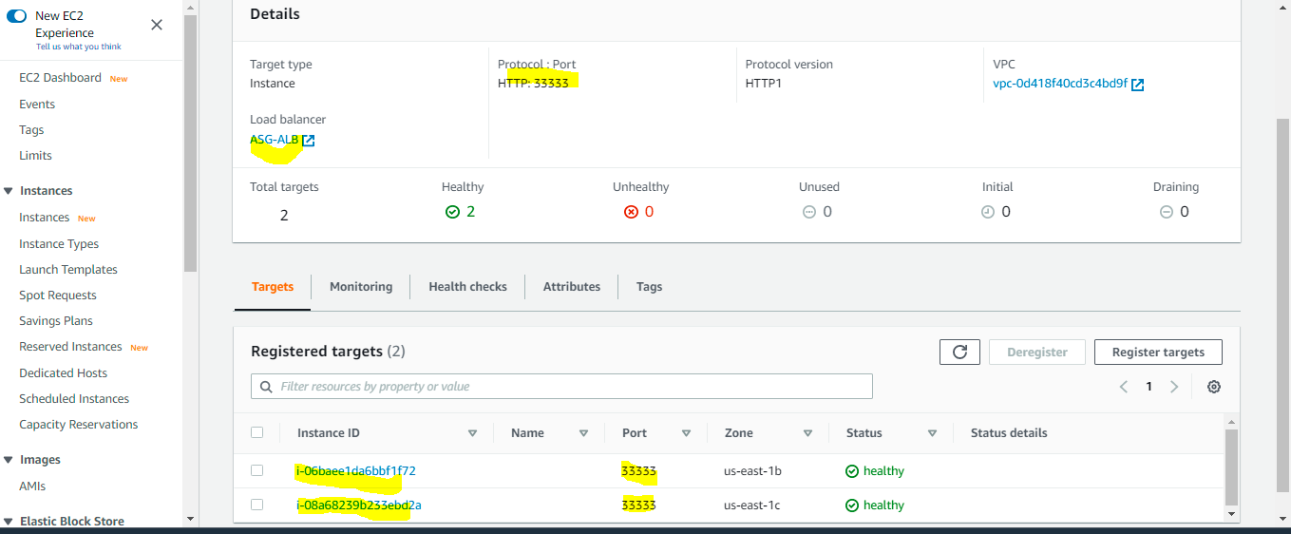

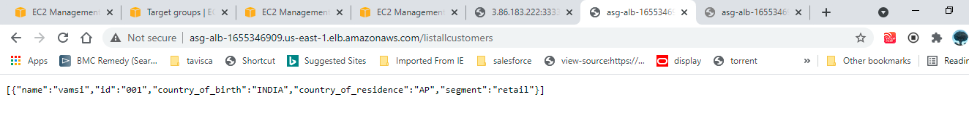

In the instance tab we can see two new instanced are created and provisioned.

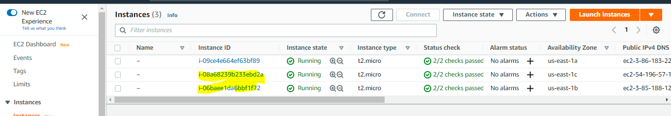

**6. Create a Updated_AMI with updated EC2 springboot application.**

For now, I am updating the existing springboot application and generating new jar file. Then will create updated AMI from this updated EC2 instance.

[root@ip-172-31-54-101 springboohello-CICD**]# pwd**

/opt/springboohello-CICD

[root@ip-172-31-54-101 springboohello-CICD]#

[root@ip-172-31-54-101 springboohello-CICD]**# cd src/main/java/org/example**

[root@ip-172-31-54-101 hello**]# ll**

total 12

-rw-r--r-- 1 root root 493 May 12 17:30 App.java

-rw-r--r-- 1 root root 545 May 12 17:30 CustomerController.java

-rw-r--r-- 1 root root 1711 May 12 17:30 Customer.java [root@ip-172-31-54-101 hello**]# cat CustomerController.java**

package org.example;

import org.springframework.web.bind.annotation.*;

import java.util.Arrays;

import java.util.List;

@RestController

public class CustomerController {

//create a customer

@PostMapping("/createnewcustomer")

public String createNewCustomer(@RequestBody Customer customer){

return "customer created";

}

//list all customers

@GetMapping("/listallcustomers")

public List<Customer> getAllCustomers(){

return Arrays.asList(new Customer("Tushar","001","INDIA","AP","retail"));

}

}

# mvn clean install

# service helloworld restart

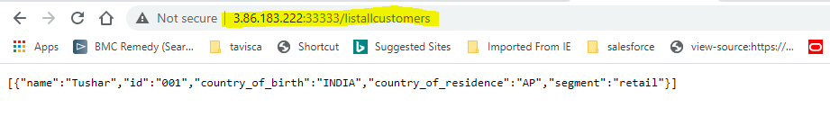

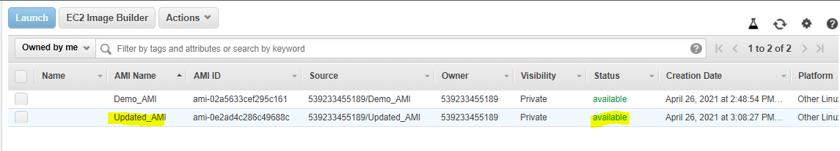

**6. Create a New Launch Configuration with Updated_AMI**

We are now creating the new launch configuration “LC_Updated_AMI” with updated AMI and instance_type if t2.mediaum.

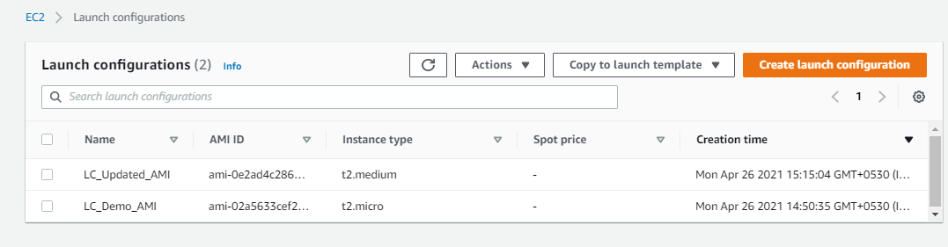

**7. Edit the scaling group and update it with Launch Configuration : “Updated_AMI”**

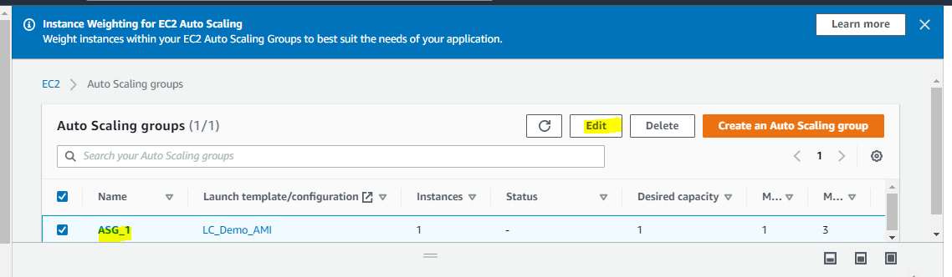

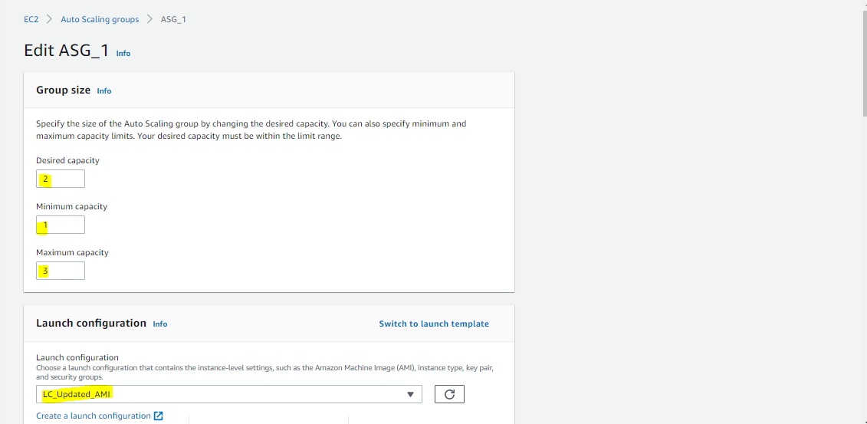

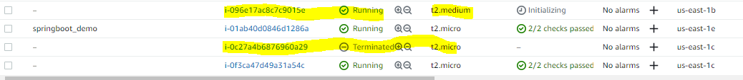

Now terminate the running old EC2 instance as well, ASG will launch the new EC2 instance with t2.medium

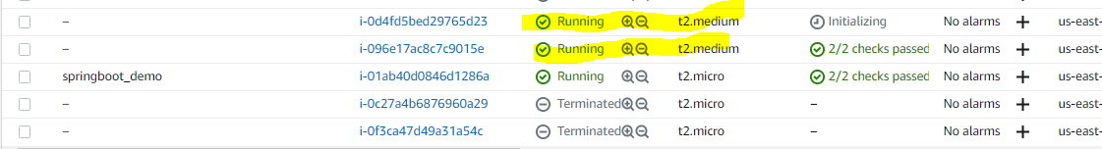

**8. Check the ALB DNS output**